|  |  |
| --- | --- |
| Course Name | ITD 2313 – Script Programming |
| Instructor | Mark L. Pranger |
| Student Name | Thomas Webb |
| Due date | 6/10/2025 |
| Grade | Put grade earned here |
| Grading Comments | Put instructor comments here |

**Page 88**

**Example code 1**

**Example code 2**

**Example 3**

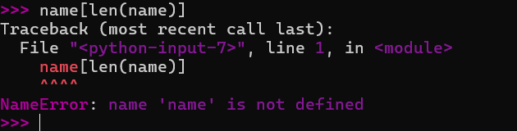

**Page 89**

**Example Code 1**

**Page 90**

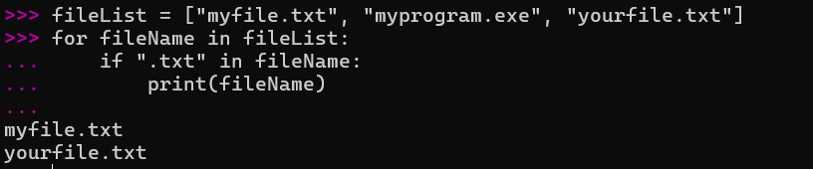

**Page 91 -92**

**Encrypt**

**Decrypt**

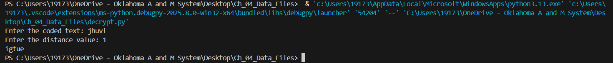



**Page 94**



**Page 95**

**Page 97**

**Example code 1**

**Page 99**

**example code 1**

**Example code 2**

**Page 101**

**Page 103**

**Sadly not availible due to issue**

**Page 106**

